AVELEIGH, NEWBERRY’S FAMILY CHURCH SUNDAY JAN. 10, 2021
SERMON SERIES: REFUELED TO COMPLETE THE JOURNEY
SERMON "THE ANCHOR OF OUR SOUL"
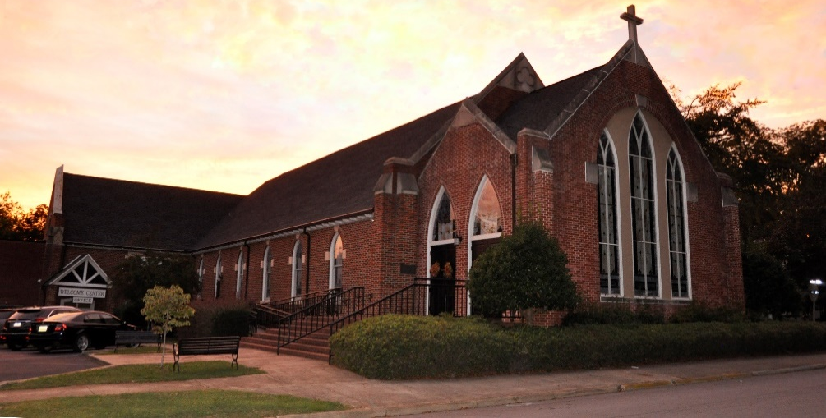

Aveleigh’s LIvESTREAM BULLETIN & ADULT HOME SUNDAY SCHOOL
For additional info and assistance text 803 944-0416
TEXT: HEBREWS 6:13-20 NIV
¹³ When God made his promise to Abraham, since there was no one greater for him to swear by, he swore by himself, ¹⁴ saying, “I will surely bless you and give you many descendants.” ¹⁵ And so after waiting patiently, Abraham received what was promised. ¹⁶ People swear by someone greater than themselves, and the oath confirms what is said and puts an end to all argument. ¹⁷ Because God wanted to make the unchanging nature of his purpose very clear to the heirs of what was promised, he confirmed it with an oath. ¹⁸ God did this so that, by two unchangeable things in which it is impossible for God to lie, we who have fled to take hold of the hope set before us may be greatly encouraged. ¹⁹ We have this hope as an anchor for the soul, firm and secure. It enters the inner sanctuary behind the curtain, ²⁰ where our forerunner, Jesus, has entered on our behalf. He has become a high priest forever, in the order of Melchizedek.

For in home worship preparation before viewing the livestream:
Call to worship: Leader: O God, be not far from us,
People: For we are your children.
Leader: O God, help us to believe,
People: For in Christ we would live abundantly.
Leader: O God, we search for you and would worship you,
People: For in you we live and move and have our being.
Apostles Creed
I believe in God the Father Almighty, maker of Heaven and earth and in Jesus Christ, His only Son, our Lord, who was conceived by the Holy Spirit. born of the Virgin Mary, suffered under Pontius Pilate, was crucified, dead and buried; He descended into hell; the third day He rose again from the dead. He ascended into Heaven and sitteth on the right hand of God the Father Almighty; From thence He shall come to judge the living and the dead. I believe in the Holy Spirit, the Church universal, the communion of saints, the forgiveness of sins, the resurrection of the body, and the life everlasting. Amen

Prayer of Confession
We confess without reservation that our dialogue with You, O God, is not really a dialogue. Too often, we ask without listening, complain without offering thanksgiving. We pray and cannot understand why we get no response. Awaken us to wonder: If You called, would we answer? Or would You get a busy signal? Would You leave a message, and get no answer in return? We confess anew our impatience and our unwillingness to sit in the holy stillness of Your presence. Forgive us, loving God. Thank You for letting us try again. In this hour of worship, let us be still and listen to what You would say to us this day. AMEN

The Lord’s Prayer
Our Father, who art in heaven, hallowed be Thy name. Thy kingdom come. Thy will be done on earth as it is in heaven. Give us this day our daily bread. And forgive us our debts, as we forgive our debtors. And lead us not into temptation but deliver us from evil. For Thine is the kingdom, and the power, and the glory, forever. Amen.

AVELEIGH, NEWBERRY’S FAMILY CHURCH - SUNDAY, JAN. 10, 2021
SERMON SERIES: REFUELED TO COMPLETE THE JOURNEY
SERMON: "THE ANCHOR OF OUR SOUL"
TEXT: HEBREWS 6:13-20 NIV
¹³ When God made his promise to Abraham, since there was no one greater for him to swear by, he swore by himself, ¹⁴ saying, “I will surely bless you and give you many descendants.” ¹⁵ And so after waiting patiently, Abraham received what was promised. ¹⁶ People swear by someone greater than themselves, and the oath confirms what is said and puts an end to all argument. ¹⁷ Because God wanted to make the unchanging nature of his purpose very clear to the heirs of what was promised, he confirmed it with an oath. ¹⁸ God did this so that, by two unchangeable things in which it is impossible for God to lie, we who have fled to take hold of the hope set before us may be greatly encouraged. ¹⁹ We have this hope as an anchor for the soul, firm and secure. It enters the inner sanctuary behind the curtain, ²⁰ where our forerunner, Jesus, has entered on our behalf. He has become a high priest forever, in the order of Melchizedek.
INTRODUCTION: ABSOLUTE CLAIMS ARE THINGS YOU SHOULD NEVER SAY ABOUT OTHERS….
Why: ABSOLUTE CLAIMS never apply to people, places, crisis, or circumstances, because
only God is immutable, unchangeable, absolute.

1. GOD’S PROMISES NEVER CHANGE.
NO ONE WHO TRUSTS IN GOD'S PROMISES WILL EVER BE DISAPPOINTED.
Yes, we may become impatient. Yes, we often expect immediate answers. Yes, we want
things done on our schedule rather than God's. But if God promised something, He will do it.
So, like Abraham, patiently trust in God and His promises.
(Heb 6:13-15) When God made his promise to Abraham, since there was no one greater for
him to swear by, he swore by himself, (14) saying, "I will surely bless you and give you many
descendants." (15) And so, after waiting patiently, Abraham received what was promised.

2. GOD'S OATH NEVER CHANGES.
Hebrews 6:13 tells us that when God made His promises to Abraham, He swore an oath.
Since there was no one greater for Him to swear by, He swore by Himself (Heb 6:13).
God does not lie. His word does not change. There is no shadow of deceit or change in Him:
(Num 23:19)

3. GOD'S TRUTH NEVER CHANGES.
(Heb 6:18) God did this so that, by two unchangeable things in which it is impossible for God
to lie, we who have fled to take hold of the hope offered to us may be greatly encouraged.
God's promise and God's oath are both unchangeable so God cannot lie.
(1 Sam 15:29) He who is the Glory of Israel does not lie or change his mind; for he is not a
man, that he should change his mind.
(Isa 40:6-8) "All men are like grass, and all their glory is like the flowers of the field. (7) ...
(8) The grass withers and the flowers fall, but the word of our God stands forever."

4. SO OUR HOPE DOES NOT CHANGE.
Christ remains for us "an anchor for the soul, firm and secure" (Heb 6:19).
5. OUR HOPE IS LIKE AN ANCHOR; IT KEEPS PULLING US
FORWARD.
(Heb 6:19-20) We have this hope as an anchor for the soul, firm and secure. It enters the
inner sanctuary behind the curtain, (20) where Jesus, who went before us, has entered on our
behalf. He has become a high priest forever, in the order of Melchizedek.

Our hope is to dwell with God. There, we will be His people and He will be our God. There,
He will wipe every tear from our eyes. There, there will be no more death or mourning or
crying or pain (Rev 21:3-4).
Conclusion: In a changing world, ours is a promise that is always kept. In a troubled world, ours is an oath that is never broken. In a world where truth is whatever you want it to be, ours is a truth that never changes. In a world where men put their hope in aliens and science and computers and comets and crystals, ours is a hope that is always sure.
Ultimately, it all comes down to Jesus. God's promise is in Jesus. God's oath is in Jesus. God's truth is in Jesus. God's hope is in Jesus. It is Jesus Who is the anchor of our soul. And it is to Jesus that we flee as we face a troubled, decaying, and changing world.
Prayer: Loving Father, thank You for the wonderful reassurances of our security in Christ, which You have graciously poured out upon us in such super-abundance and which You have confirmed throughout Your holy Word, by many precious promises. We praise You for Your boundless grace and unchangeable character and we bless You that Jesus is our perfect heavenly representative, who has gained for us eternal access into Your holy presence, through the willing sacrifice of Himself upon the cross of Calvary. We bless Your holy name, in Christ. AMEN.

Sunday Worship Theme Discussion Guide
Jan. 10, 2021
THE ANCHOR OF YOUR SOUL
TALK IT OVER
Aveleigh’s Adult ZOOM Sunday School
Group

Hebrews 6:13-20, ¹³ When God made his promise to Abraham, since there was no one greater for him to swear by, he swore by himself, ¹⁴ saying, “I will surely bless you and give you many descendants.” ¹⁵ And so after waiting patiently, Abraham received what was promised. ¹⁶ People swear by someone greater than themselves, and the oath confirms what is said and puts an end to all argument. ¹⁷ Because God wanted to make the unchanging nature of his purpose very clear to the heirs of what was promised, GOD confirmed it with an oath. ¹⁸ God did this so that, by two unchangeable things in which it is impossible for God to lie, we who have fled to take hold of the hope set before us may be greatly encouraged. ¹⁹ We have this hope as an anchor for the soul, firm and secure. It enters the inner sanctuary behind the curtain, ²⁰ where our forerunner, Jesus, has entered on our behalf. He has become a high priest forever, in the order of Melchizedek.
OPEN YOUR MEETING, SHARE A WELCOME, RECOGNIZE ANY GUEST and SHARE PRAYER REQUESTS AND GROUP PRAYER. Hebrews 6:19, "The Anchor of our Soul"
Introduction: One of the things Pastor Mitch discusses in pre-marital counseling is circuit jammers that prevent or destroy communication and relationship. These are things you should never say to your spouse; in fact, you should never say them to anyone:
-You never do a good job at anything you do.
-I always do what I set my mind to do.
-You never care about what I think.
-You are never satisfied.
-It is always your fault.
-I always have to tell you this again and again.
1. TALK ABOUT IT; WHY SHOULD WE BE CAUTIOUS HOW WE USE ABSOLUTE
STATEMENTS?
2. DISCUSS: HERE IS THE BIG POINT; people, circumstance, and all the stuff of mortal life
will always be changing. Life itself will be filled with changing challenges. BUT HERE IS
THE ANSWER: GOD NEVER CHANGES.

Because words like "never" and "always" all absolute claims only apply to God.
Because God is always the same. The theological word we use for this is immutable.
God is immutable. This means God cannot and does not change. God is always eternal, incomprehensible, invisible, infinite, almighty, completely wise, just, good, and the overflowing source of all good. Whoever and whatever God is, He always is. Whoever and whatever God isn't, He always isn't. TALK ABOUT IT.

TALK ABOUT IT: How might faith in the immutable God save you from your current circumstances? Challenges?

2. DISCUSS WHAT IT MEANS TO YOU THAT GOD'S PROMISES NEVER CHANGE
We first see that God's promises never change. As proof of this, Hebrews directs our attention
to Abraham: (Heb 6:13-15) When God made his promise to Abraham, since there was no one
greater for him to swear by, he swore by himself, (14) saying, "I will surely bless you and
give you many descendants." (15) And so after waiting patiently, Abraham received what was
promised.
REMEMBER, Abraham was childless at the age of 99. Yet, Abraham had hope and faith in God and His promises of many descendants. According to Romans, "Against all hope, Abraham in hope believed ..." (Rom 4:18). God proved faithful. When Abraham was 100 years old and Sarah was 90 years old (Gen 17:17), God blessed them with the birth of Isaac. After the death of Sarah, Abraham took another wife, and she bore him six more sons (Gen 25:1-4). Abraham did not see this, but eventually his physical and spiritual descendants did become as numerous as the stars in the sky and as the sand on the seashore.
TALK ABOUT IT; People, places, things, and circumstances may become inconsistence, But this is not true of God. God's never changes, and His oath is always kept. God cannot lie. WHAT DO YOU THINK? How might this be a comfort to you?
3. Discuss God's Truth Never Changes, (Heb 6:18) God did this so that, by two unchangeable
things in which it is impossible for God to lie, we who have fled to take hold of the hope
offered to us may be greatly encouraged. God does not lie. His word does not change. There is
no shadow of deceit or change in Him: Discuss what, God's truth never changes, means to
you.
4. Discuss, Our Hope Does Not Change, the fourth thing we see in our Bible reading is that our
hope does not change. Hebrews describes this hope as "an anchor for the soul, firm and
secure" (Heb 6:19). As you know, an anchor steadies the ship and prevents it from drifting in
stormy seas. It keeps the ship from smashing into rocks. What give you hope? How?
IS YOUR HOPE IN THE UNCHANGING GOD or PLACED IN OTHER THINGS?
Conclusion: In a changing world, how does The Certainty of God Anchor you and yours?

PRAYER, Loving Father, thank You for the wonderful reassurances of our security in Christ, which You have graciously poured out upon us in such super-abundance and which You have confirmed throughout Your Holy Word, by many precious promises. We praise You for Your boundless grace and unchangeable character and we bless You that Jesus is our perfect heavenly representative, who has gained for us eternal access into Your holy presence, through the willing sacrifice of Himself upon the cross of Calvary. We bless Your holy name, in CHRIST. AMEN.

