Aveleigh’s LIvESTREAM BULLETIN & ADULT HOME SUNDAY SCHOOL
For additional info and assistance text 803 944 0416

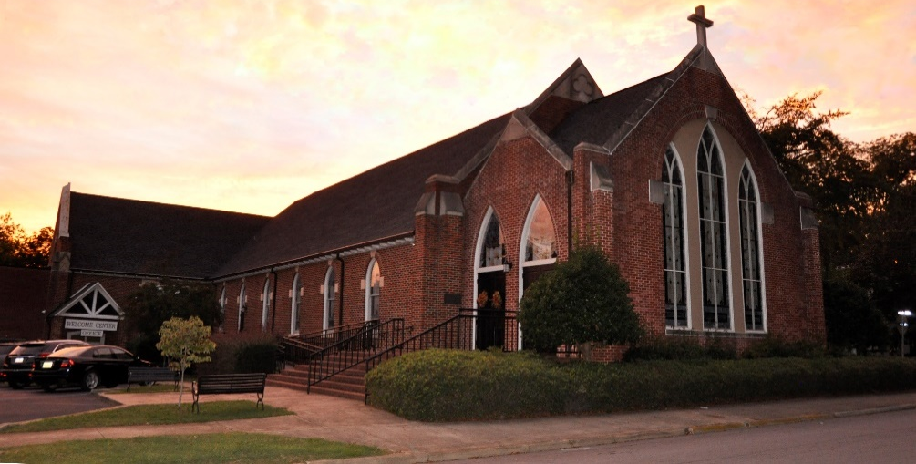
SUNDAY, JUNE 13, 2021
SERMON SERIES: GOD’S GREAT CALLINGS (Week 1 0f 5)
SERMON TITLE: YOU’RE CALLED TO BE LOVED
TEXT: LUKE 15: 17-24 (NIV) “When he came to his senses, he said, ‘How many of my father’s hired servants have food to spare, and here I am starving to death! I will set out and go back to my father and say to him: Father, I have sinned against heaven and against you. I am no longer worthy to be called your son; make me like one of your hired servants.’ So he got up and went to his father. “But while he was still a long way off, his father saw him and was filled with compassion for him; he ran to his son, threw his arms around him and kissed him. “The son said to him, ‘Father, I have sinned against heaven and against you. I am no longer worthy to be called your son.’ “But the father said to his servants, ‘Quick! Bring the best robe and put it on him. Put a ring on his finger and sandals on his feet. Bring the fattened calf and kill it. Let’s have a feast and celebrate. For this son of mine was dead and is alive again; he was lost and is found.’ So they began to celebrate”.

For in home worship preparation before viewing the livestream:
Call to Worship:
Leader: Let your lives witness to Christ’s love,
People: And may our words bring reconciliation.
Leader: Let your thoughts be of peace.
People: And our touch bring healing.
Leader: Let your actions count for justice,
People: And may our faith be a sign of hope.
Leader: Let our time of worship here and now be a true blessing for us all and restore joy and
praise to our lives.

Apostles Creed
I believe in God the Father Almighty, maker of Heaven and earth and in Jesus Christ, His only Son, our Lord who was conceived by the Holy Spirit, born of the Virgin Mary, suffered under Pontius Pilate, was crucified, dead and buried. He descended into hell, the third day He rose again from the dead. He ascended into Heaven and sitteth on the right hand of God the Father Almighty. From thence He shall come to judge the living and the dead. I believe in the Holy Spirit, the Church universal, the communion of saints, the forgiveness of sins, the resurrection of the body, and the life everlasting. Amen

Prayer of Confession
Though we run so far away, we are never lost from you. Though we take everything for granted and dismiss your grace, you never leave us or forsake us. O Lord, we confess our tendencies to wander and to forget that all good things come from you. We become so self-absorbed that we don't see you sitting right next to us, desiring to wrap your arms around us. Open our eyes to your presence. Free us from the desire to take life into our own hands. Thank you for always welcoming us home when we choose to trust our own ways and make our own paths. We choose today to follow only you. Amen.

The Lord’s Prayer
Our Father, who art in heaven, hallowed be Thy name. Thy kingdom come. Thy will be done on earth as it is in heaven. Give us this day our daily bread. And forgive us our debts, as we forgive our debtors. And lead us not into temptation but deliver us from evil. For Thine is the kingdom, and the power, and the glory, forever. Amen.

AVELEIGH, NEWBERRY’S FAMILY CHURCH, SUNDAY JUNE 13, 2021
SERMON SERIES: GOD’S GREAT CALLINGS (Week 1 0f 5)
SERMON TITLE: YOU’RE CALLED TO BE LOVED
TEXT: LUKE 15:17-24 (NIV) “When he came to his senses, he said, ‘How many of my father’s hired servants have food to spare, and here I am starving to death! I will set out and go back to my father and say to him: Father, I have sinned against heaven and against you. I am no longer worthy to be called your son; make me like one of your hired servants.’ So he got up and went to his father. “But while he was still a long way off, his father saw him and was filled with compassion for him; he ran to his son, threw his arms around him and kissed him. “The son said to him, ‘Father, I have sinned against heaven and against you. I am no longer worthy to be called your son.’ “But the father said to his servants, ‘Quick! Bring the best robe and put it on him. Put a ring on his finger and sandals on his feet. Bring the fattened calf and kill it. Let’s have a feast and celebrate. For this son of mine was dead and is alive again; he was lost and is found.’ So they began to celebrate.”
INTRO POINT: TO UNDERSTAND YOUR CHRISTIAN CALLING - BEGIN WITH
GOD’S NATURE BECAUSE GOD CREATED YOU - TO LOVE YOU!
Eph. 1:4-5 (NLT) “Long ago, even before he made the world, God loved us and chose us in Christ to be holy and without fault in his eyes. His unchanging plan has always been to adopt us into his own family by bringing us to himself through Jesus Christ. And this gave him great pleasure.”

INTRO POINT: OUR FIRST CHRISTIAN CALLING IS TO BE LOVED BY GOD!
- NOT to serve him... obey... trust...do something for him. Just LET GOD LOVE YOU!
Jude 1:1 “This letter is from Jude, a servant of Jesus Christ and a brother of James. I am writing to all who are called to live in the love of God the Father and in the care of Jesus Christ.”

WHAT CHANGES IF WE STAY CONTINUALLY AWARE OF GOD’S CONSTANT LOVE FOR US?

1. WE FEEL ACCEPTED RATHER THAN ASHAMED.
Most people avoid God because of feeling ashamed, guilty, judged etc.

Romains 5:1 (CEV) “By faith we have been made acceptable to God. And now, because of our Lord Jesus Christ, we live at peace with God.”
This sets you free from approval addiction and from worries about being accepted by
others.

Criticism doesn’t bother you if the Creator of YOU says...OK!
Romans 8:33-34 (CEV) “If God says his chosen ones are acceptable to him, can anyone bring charges against them? Or can anyone condemn them? No indeed!”
Fact: We don’t need other’s approval to be happy!

2. WE’RE BOLD IN BRINGING OUR NEEDS TO GOD.
Rom. 8:14-15,17 (NLT) “All who are led by the Spirit of God are children of God! So, you
should not be like cowering, fearful slaves. You should behave instead like God's very own
children, adopted into his family—calling him ‘Father, dear Father.’ ... And since we are his
children, we will share his treasures—for everything God gives to his Son, Christ, is ours,
too.”

3. WE HAVE PEACE IN PAIN WE DON’T UNDERSTAND.
Phil. 4:7 “The peace of God, which passes all understanding, will keep your hearts
and minds through Christ Jesus.” What is it?

God’s love doesn’t exempt you from pain and dumb decisions, BUT WE DO HAVE THIS
PROMISE... Rom. 8:28 “And we know that in all things God works for the good of those who
love him, who have been called according to his purpose.”

4. WE GAIN THE COURAGE TO TAKE RISKS.
1 John 4:18 (NIV) “There is no fear in love. But perfect love drives out fear, because fear has
to do with punishment.”

5. WE WORSHIP INSTEAD OF WORRY!
Worship is expressing my love to God (always a response) We love him. God takes the
initiative: 1 John 4:19 (NIV) “We love because God first loved us.”

So how do I become a son or daughter of God?
John 1:12 (NLT) “To all who believed him and accepted him, Jesus gave the right to become
children of God.”

THIS WEEK’S MEMORY VERSE
Romans 6:13 (NLT) “Give yourselves completely to God since you
have been given new life.”

PRAYER: Dear God, I am amazed at how much You love me. Thank You that Your love for me is deep enough to handle all my problems and high enough to overlook my sins because of Jesus. God, I want to feel accepted rather than ashamed. I want to be bold in bringing my needs to You. I need the peace that passes understanding. I want to have peace even in pain that I don’t understand. I need Your love to give me the courage to take risks, to go after my dreams. Jesus Christ, as best as I know how, I surrender every particle and room of my life. I want to learn to love You back because You love me so much. I want to spend the rest of my life with that first calling of letting You love me. I pray this in Jesus name. Amen.

TALK IT OVER
Sunday Worship Theme Discussion Guide
Sunday June 13, 2021 SERIES: GOD’S GREAT CALLINGS (Week 1 of 5)
SERMON TITLE: YOU’RE CALLED TO BE LOVED

Aveleigh’s Adult ZOOM SUNDAY SCHOOL

OPEN YOUR MEETING, SHARE A WELCOME, RECOGNIZE ANY GUEST and SHARE PRAYER REQUESTS AND GROUP PRAYER

- Icebreaker: When have you been surprised to be treated as “one of the family” – perhaps when a coach or teacher took you under their wing at school, or a colleague mentored you and helped you to advance at work?
“Long ago, even before he made the world, God loved us and chose us in Christ to be holy and without fault in his eyes. His unchanging plan has always been to adopt us into his own family by bringing us to himself through Jesus Christ. And this gave him great pleasure.”
Ephesians 1:4-5 (NLT)

Open your group with a prayer. This is only a guide – select the points you want to discuss.

Reopening, restarting, renewing old relationships; literally today is a day of renewal. A gifted time for us to reflect on that which matters most. What truths matter most to you? What values and purposes define who you are becoming? The first God Calling of our lives is to let God love us. In fact, our first calling is to enjoy a relationship forever with God. This is important in answering the question, “What on earth am I here for?” From the sermon outline this day, staying aware of God’s constant love for us produces five significant changes in our lives: (1) we feel accepted rather than ashamed, (2) we’re bold in bringing our needs to God, (3) we have peace in pain we don’t understand, (4) we gain the courage to take risks, and (5) we worship instead of worry!

- Read Ephesians 1:4-5 printed above top of page. How does this verse indicate we are called to be loved? How do you connect with the truth of divine adoption?

Ephesians 1:4-5 above indicates that God loved us before he even made the world having planned to adopt us into his own family. God’s love for us is constant on both our good and bad days. What do you think?

READ TOGETHER: “I pray that Christ will be more and more at home in your hearts as you trust in him. May your roots go down deep in the soil of God’s marvelous love. And may you have the power to understand, as all God’s people should, how WIDE, how LONG, how HIGH, and how DEEP his love really is. May you EXPERIENCE the love of Christ though it is so great you will never fully understand it.” Ephesians 3:17-19 (NLT)

- After reading Ephesians 3:17-19 discuss how we might experience the love of Christ through a relationship with God as His own son or daughter.

- Meditate on Ephesians 3:17-19 above, specifically on how God’s love for us is so wide, long, deep, and high. God’s love is high enough for Him to overlook every mistake we’d ever make. As we grow in understanding of how much God loves us, how does that help us to grow in love for God?

“If God says his chosen ones are acceptable to him, can anyone bring charges against them?
Or can anyone condemn them? No indeed!” Romans 8:33-34 (CEV)
- Read Romans 8:33-34 above. Many people live for the approval of others, even those who have already passed on. Whose approval are you seeking? Sadly, people run from God because they feel ashamed instead of accepted. Imagine fully accepting God’s unconditional love as His chosen child. What needs would you boldly bring to Him? What charges do some people commonly bring against others that this verse says they cannot?

“There is no fear in love. But perfect love drives out fear, because fear has to do with punishment.” 1 John 4:18 (NIV)
- Often people lack peace when they struggle with pains or problems they don’t understand. However, God wants us to trust Him. How can 1 John 4:18 gives us courage to take risks, especially in areas of our lives where dreams may not yet be realized? Be specific in sharing the types of action you would take in order to take a risk where God is calling you.

“Give yourself completely to God, since you have been given new life.” Romans 6:13b (NLT)
- Worry indicates that we are not fully living the new life given to us and is often a warning sign that we are not living in God’s love. Worship is simply telling God we love Him, whether at church, with others, or alone. Worship is always a response because God first loved us. How can you remind yourself to worship the next time you begin to worry?

Diving Deeper (optional)

- If our first purpose in life is to be loved by God, we must overcome obstacles that prevent us from fully receiving His love. How would your life change if you felt God loved you ever moment of your life regardless of any mistakes you’ve made in the past or may make in the future? How has God freed you from mistakes you’ve made in the past, and how might he free you from mistakes you’re still holding onto today?

- See Romans 6:13 above. In light of the fact that we’ve been given new life, how might we give ourselves more completely to God? In what ways have you not given yourself completely to God?

Review any assignments or commitments made during your previous meeting.

Prayer: Father, I take this moment to fully receive the unconditional love You’ve always had for me. Forgive me for all that I have done that does not reflect Your love. Thank You for Your grace, mercy, and forgiveness, which I also fully receive right now. Help me to remember to receive Your love each moment of the day, that I may fully worship You and love others, as You have loved me. In Christ’s name, Amen.

